**MODULE: 9 ReactJs Intro**

**\*What is React Js?**

- React.js, or React, is an open-source JavaScript library used for building user interfaces or UI components, particularly for single-page applications where UI updates are frequent.

**\*What is NPM in React Js?**

- NPM stands for Node Package Manager. It is a package manager for JavaScript that allows developers to share and reuse code. In the context of React.js, NPM is commonly used to install and manage third-party libraries and tools.

**\*What is the Role of Node Js in React Js?**

- Node.js is used in the React.js development environment to run the build scripts, manage dependencies, and perform various development-related tasks. It provides a runtime for executing JavaScript code outside the browser, which is essential for server-side rendering and build processes.

**\*What is CLI command In React Js?**

- The CLI (Command Line Interface) commands in React.js are tools that help with tasks like creating a new React application, running development servers, and building production-ready code. The most common one is `create-react-app` for creating a new React project.

**\*What is Components in React Js?**

- Components are the building blocks of a React application. They are reusable and self-contained pieces of code that encapsulate a part of the user interface. Components can be either functional or class-based and are composed together to create the entire UI.

**\*What are Header and Content Components in React Js?**

- Header and Content Components are specific types of React components. The Header component typically contains elements like navigation menus, logos, or any information displayed at the top of a page. The Content component, on the other hand, holds the main content of the page.

**\*How to install React Js on Windows, Linux Operating System? How to Install NPM and How to check version of NPM?**

-To install React.js on Windows or Linux, you can use the `create-react-app` command. To install NPM, it usually comes with Node.js. To check the version of NPM, use the command `npm -v`. For React.js, after installation, you can check the version with `react --version` or `npm list react`.

**\*How to check version of React Js?**

-You can check the version of React.js using the command `react --version` or by checking the version within your project's `package.json` file.

**\*How to make changes in components of React Js?**

-To make changes in React components, you edit the corresponding JavaScript or JSX files. If it's a class component, you modify the `render` method, and for functional components, you update the function body. State and props are commonly used to manage dynamic content, and changes are reflected automatically when state or props are updated.

**\*How to Create a List View in React Js?**

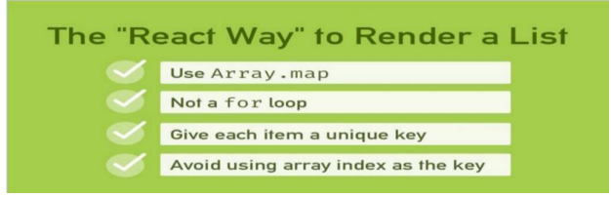

* **List**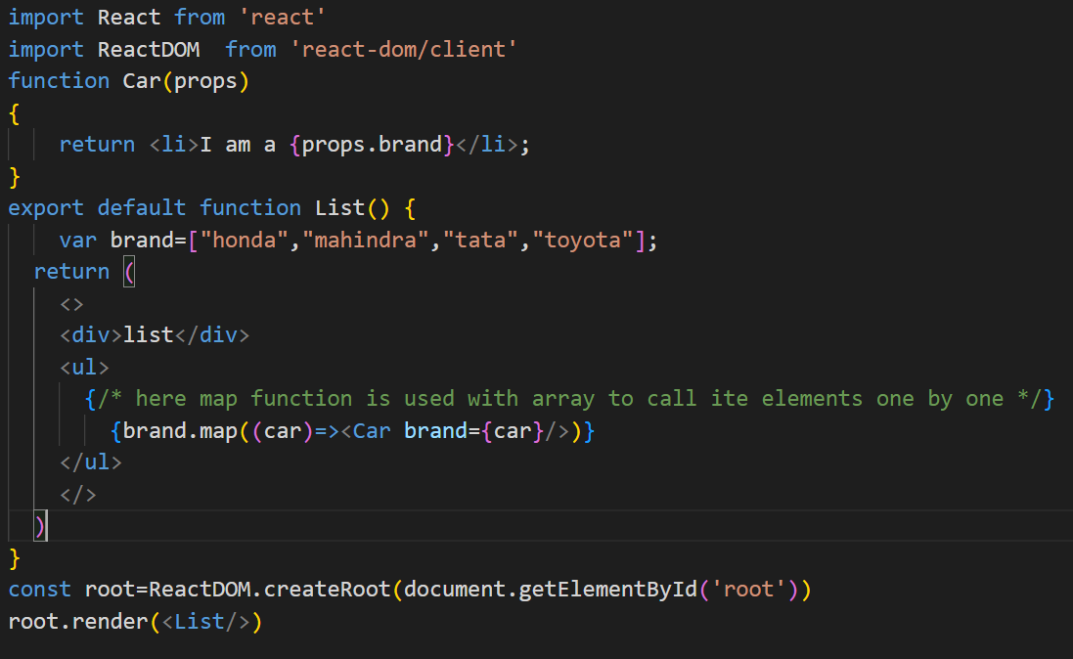
* **App.js**

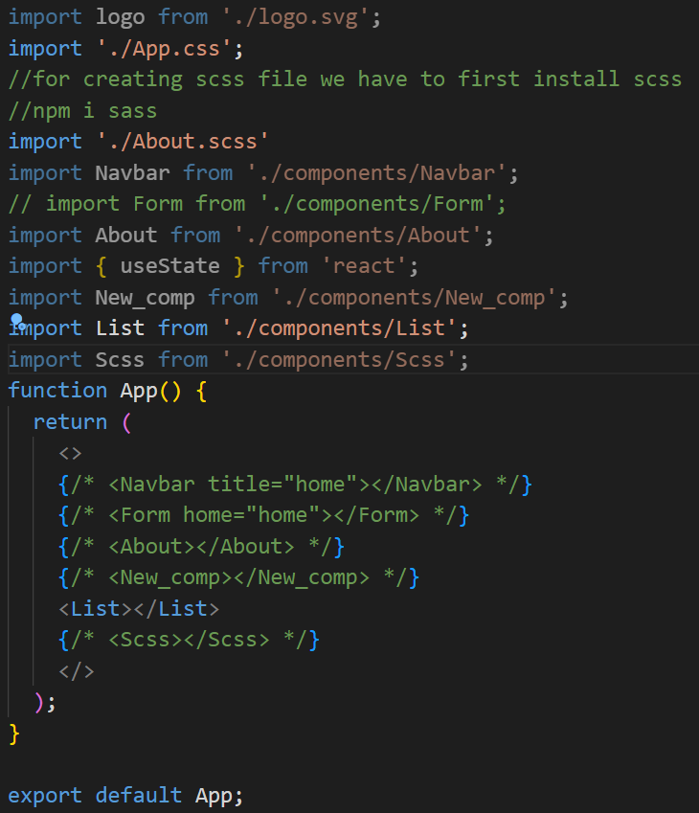

* **Output**

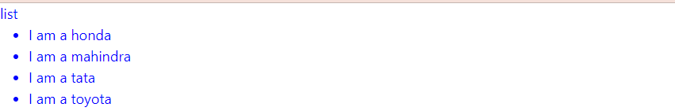

**\*Create Increment decrement state change by button click?**

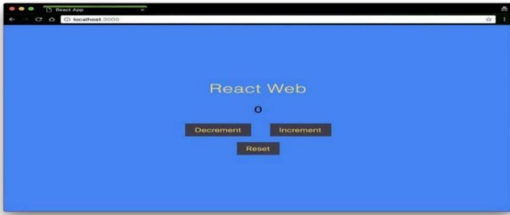

* **App.js**

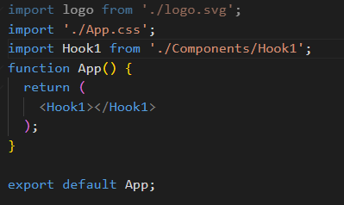

* **Hook1.js**

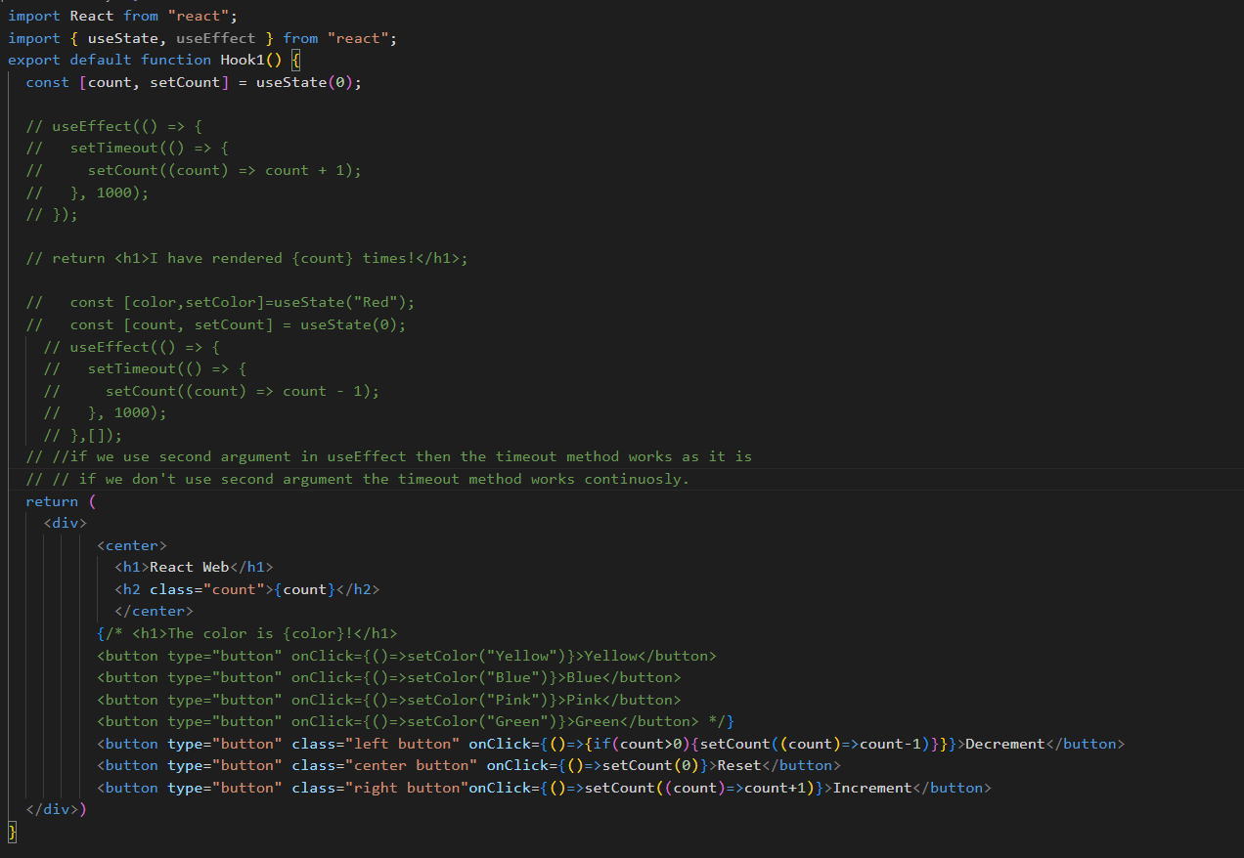

* **Index.css**

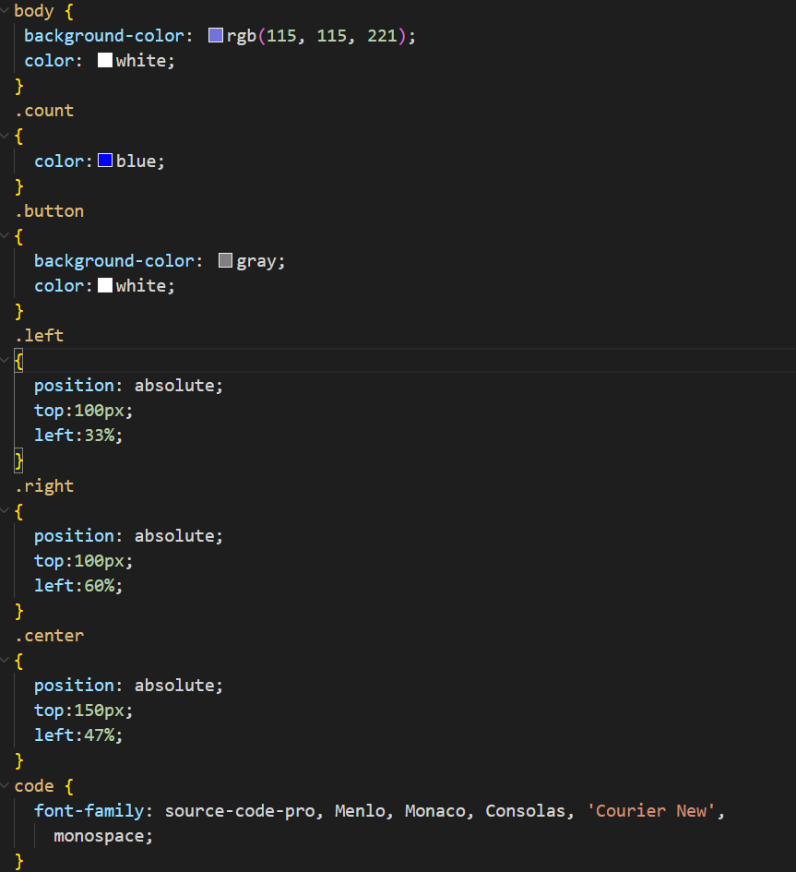

* **Output**

